PROFILE VERIFICATION – DATA ENTRY GUIDELINES
Demographics tab
Last name | - Legal last name  - Use proper case
First name | - Legal first name  - Use proper case
Middle Name | - Legal middle name  - Use proper case
Alternate First Name | - This field should be blank unless Alternate First Name is DIFFERENT from Legal first name  - Use proper case
Alternate Last Name | - This field should be blank unless Alternate Last Name is DIFFERENT from Legal Last name, i.e. maiden name  - Use proper case
Legal Gender | - Select Female or Male (corresponds with gender on documentation)
Date of Birth | - Format is mm/dd/yyyy
Personal Education Number | What is a Personal Education Number?  - Students entering B.C.’s education system are assigned a Personal Education Number (PEN) - a unique nine-digit number. If they attended a B.C. K-12 school since 1993, wrote a provincial exam since 1986 or attended a B.C. Public Post-Secondary Institution since 1998, they MAY have a PEN.  - This field will be blank for most new profiles  - If student is in MyEd, update with PEN from MyEd.
Social Insurance Number | - For BCJS students ONLY, otherwise field should be blank  - This is an encrypted field and is not available for viewing by staff
Status in Canada | School-aged  - To be consistent with MyEd, it is the citizenship status of the parent that is to be entered in the Status in Canada field  Adult  - Selection is based on status in Canada documentation  NOTE: See pages 4 and 5
PRC Number | - Required for LINC students only
Country of Birth | - As entered by student or verified in MyEd
Home Language | - As entered by student or verified in MyEd
PROFILE VERIFICATION – DATA ENTRY GUIDELINES
Demographics tab
International Funding Eligible | - Default is N/A  - No - If status is International  - Yes - If status is International Funding Eligible
Work/Study Permit Expiry Date | - If status is International Funding Eligible, enter the work/study permit expiry date  NOTE:  If Refugee documentation is accompanied by a work permit, DO NOT enter the work permit expiry date in this field. Status is REFUGEE, NOT INTERNATIONAL FUNDED
Graduation Status | Has the student graduated high school? Select either:  - Yes, I have graduated high school  - No, I have not graduated high school
Year of Grad | - Currently we are not using this field
Graduation Program | Selections are:  - 2018 (80 credit)  Students in Grades 10 and 11 in the 2017/18 school year – and beyond – are on the 2018 Graduation Program.  - 2004 (80 credit)  Students who graduated prior to July 2018 were on the 2004 Graduation Program.  - 1996 (52 credit)  - 1986 (13 course)  - 1950 (Adult)  Students must be 18 years of age or older or have the principal’s approval to enroll in the Adult Graduation Program.
Grade Level | - For non-graduated school-aged students, select the appropriate grade level (Kindergarten through Grade 12)  - For graduated school-aged students and non-graduated/graduated adults, the selection is N/A

PROFILE VERIFICATION – DATA ENTRY GUIDELINES
Demographics tab
What school are you currently attending? | - If currently in day school, the home school is the school where the student is taking most of their courses.  IF NOT IN DAY SCHOOL OR GRADUATED:  - Select Coquitlam Open Learning if the student is taking self-paced/flex-paced courses  - Select Coquitlam Continuing Education if the student is taking HSC face to face courses  - Select Coquitlam Continuing Education if the student is taking Foundations courses
Pupil Number | - The pupil number is unique to MyEd. If student is in MyEd, update with Pupil Number from MyEd.
Foundations Assessment Level | New students wishing to take a Literacy Foundations class need to complete an English language assessment at which time their Foundations Assessment Levels are determined.  - Foundations Levels 1-7:  Enter F1, F2, F3, F4, F5, F6 or F7  - Literacy Foundations Speaking & Listening Levels 1/2:  Enter S1 or S2  - Literacy Foundations Writing Levels 3-7:  Enter W3, W4, W5, W6 or W7

STATUS IN CANADA
The following provides guidelines for Status in Canada data entry in Lumens.

If Status in Canada is:
- Canadian Citizen
- Permanent Resident/Landed Immigrant
- Refugee (and Claimants)
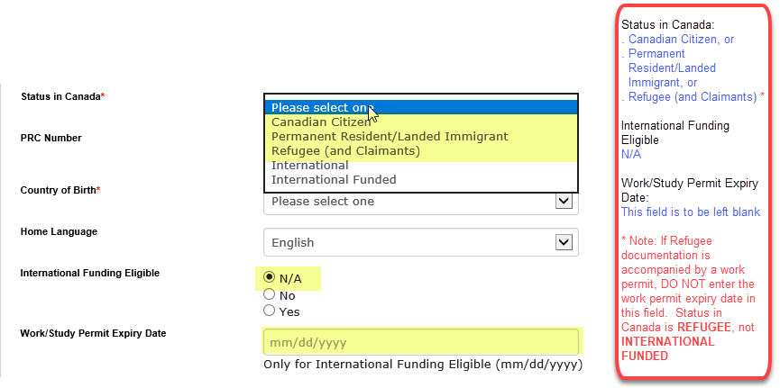

If Status in Canada is:
- International

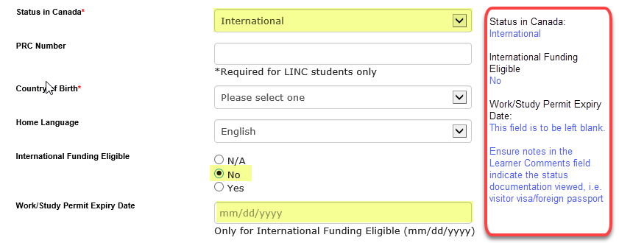

If Status in Canada is:
- International Funded
  - Work permit
  - Study permit (enrolled in degree or diploma granting program at a public or private post-secondary institution in BC)

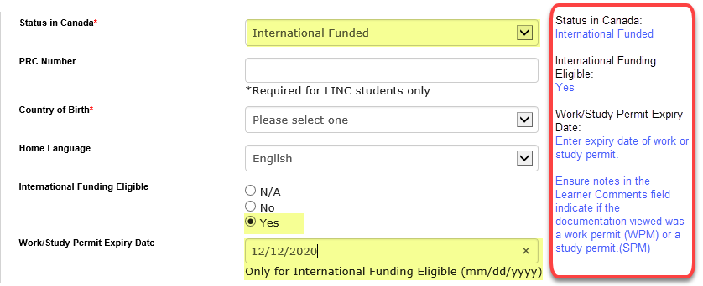

PROFILE VERIFICATION – DATA ENTRY GUIDELINES
Phone and Address tab
Primary Address
Primary Address Type | - For most of our students, the selection will be Home
Country | - Default is Canada
Line 1 > Address | - Unit/Apt number should be placed before the civic number with a hyphen in between  Example:  10-123 Main St  - Use abbreviations for Street Types  Avenue Ave  Boulevard Blvd  Circle Cir  Court Crt  Cul-de-sac CDS  Drive Dr  Place Pl  Plateau Plat  Point Pt  Private Pvt  Road Rd  Street St  Terrace Terr
Line 2 > Address
City
Province
Postal Code | - Proper formatting is V3K 5G2
Secondary Address | - These fields should only be populated if DIFFERENT from Primary Address  - Delete if SAME as Primary Address
Internal Comments | - The staff entries in this field detail the status of documentation requested for the student or provided by the student.  - Refer to Documentation Acronyms (page 7) for abbreviations to use when listing documentation
Staff Approval of Profile Documentation

DOCUMENTATION ACRONYMS
LEARNER PROFILES
PROOF OF STATUS IN CANADA
- CDN BCERT  Canadian birth certificate | - WPM  Work Permit, and proof of current employment (within last 30 days, minimum of 20 hours per week)
- CDN PP  Canadian passport | - SPM  Study permit, and  Post-secondary Letter of acceptance or transcript
- CDN CIT  Canadian Citizenship card/certificate | - NEX  Nexus Card with Citizenship listed as CAN (Canadian)
- LD  Record of Landing/Confirmation of Permanent Residence | - REF  Refugee Claimant Documentation conferring status (Convention refugee or refugee claimant)
- PRC  Permanent Resident Card (front and back) | - FN  Certificate of Indian status
PROOF OF RESIDENCY
- BCDL  BC Driver’s Licence or Enhanced BC Driver’s Licence | - BCVR  BC vehicle registration
- BCID  BC Identification (BCID) | - CDN BNK  Canadian bank account statement-showing name and address
- BCSC  BC Services Card | - CDN CR  Canadian credit card statement-showing name and address
- TENAGR  Long-term Tenancy agreement – showing name and address, OR Letter from landlord (not tenant) attesting to residency and length of tenancy | - PTS  Property tax statement-showing name and address
- PPA or MORT  Property purchase agreement or Mortgage Agreement- showing name and address | - MTB  Municipal Tax Bill
- NOA or T4  Notice of Assessment (Income Tax Statement) or T4-showing name and province of residency | - UTIL  Home or mobile phone, Hydro, Internet/Cable, Household Gas bill
- POE  Proof of Employment for a minimum of 20 hours per week (eg. Pay stub, letter from the Employer) | - OTH  Other (not listed) ___________________________________

PROFILE VERIFICATION – DATA ENTRY GUIDELINES
Parent or Guardian Information, if applicable (school-aged students ONLY)
LMS Username | O365 Username
LMS Password | O365 Password
Parent/Guardian E-mail address
Parent/Guardian legal Name
Relationship to Student
Parent/Guardian Phone Number
Parent/Guardian Cell Phone Number
Special Education Designation | - This field is relevant for in-district students, Summer Learning registrations ONLY  - When verifying the profile, the SPED Designation can be found on the Programs tab in MyEd
English Language Learning Level | - This field is relevant for in-district students, Summer Learning registrations ONLY  - When verifying the profile, the English Language Learning Level (Years of ELL) can be found on the Programs tab in MyEd
Company
O365 Test Username | ?
Moodle Test Username | ?

