Microsoft Teams Training

Microsoft Training
Select the Training Tab from the Help Menu
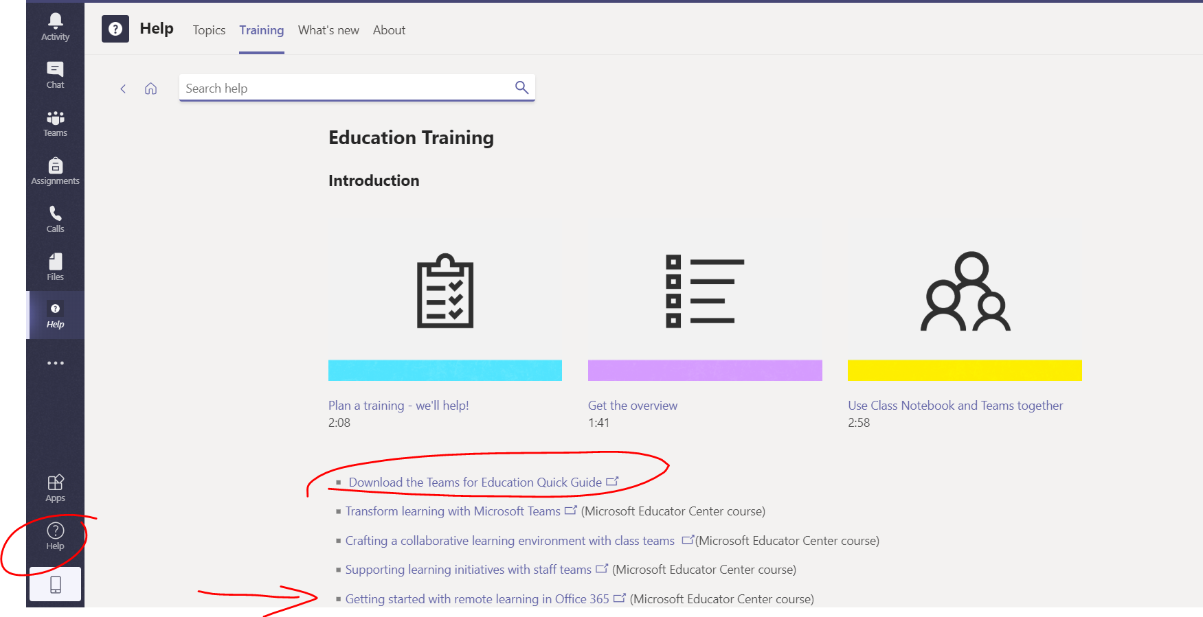
Microsoft offers an hour-long training course on using Microsoft Teams for training called “Transform Learning with Microsoft Teams”.

Lynda.com – Learning Microsoft Teams for Education
https://www.lynda.com/Microsoft-Classroom-tutorials/Types-teams/580649/647752-4.html?srchtrk=index%3a1%0alinktypeid%3a2%0aq%3amicrosoft+teams+class%0apage%3a1%0as%3arelevance%0asa%3atrue%0aproducttypeid%3a2
This is an hour-long video that takes you through using Microsoft teams for teaching. Lynda.com is free through the Public Library, visit your library’s website for more information.

