Literacy Foundations Program

Attendance, Withdrawals, Re-registration, & Reporting Policies and Procedures

Attendance & Withdrawals
Re-registration
Reporting (marks entry)
End of Course Checklist

*****************************************************************
Attendance: for instructions on how to enter attendance, click here.

Attendance & Withdrawals

These policies are based on the following principles:
- Student attendance is vital to student learning and achievement in Literacy Foundations courses
- Continuing Education and its teachers require clear instructions for handling student attendance issues and decisions about withdrawals and re-registration. Consistent implementation by all teachers is essential in that it is the fairest approach for our students.
- Continuing Education has the responsibility of communicating its policies in a clear and accessible way to all students.

Background:
Teachers have identified several key issues around attendance, withdrawals, and re-registration:
- Students who do not attend the beginning of a course and do not communicate with their teacher
- Students who have sporadic attendance throughout the course
- Students who miss a lengthy period in the middle of a course
- Students who are absent during the re-registration process (“discussions with teachers”) at the end of the course.
Communications:
- These policies will be posted on the Learn English for Free website in Lumens
- These policies will be stated in the “welcome to your new class” email sent out by the main office one or two days prior to the start of the course
- Teachers will share these policies with their new class on the first and second classes.

The following policies will take effect as of Term 3 MWF classes (Jan to Mar 2020) and Term 3 TR classes (Mar to June 2020)
Attendance & Withdrawal Policies:
Attendance & Withdrawal Policies:
- Students are registered for courses with the understanding that they are committed to attending all classes
- Students who are absent both the first and second class will be withdrawn by the office prior to the third class:
New!
“2, you’re out”
- After the second class the office will run a report to identify students who have missed both classes. Prior to the third class the office will withdraw the student and notify them by email that they have been withdrawn.
- It is the teacher’s responsibility to notify the office (Cindy Erwin cerwin@sd43.bc.ca) if there are any extenuating circumstances that should keep the student from being withdrawn.
- After the first two classes, a student who misses any two consecutive classes will be sent the following email by the teacher that day/evening:
You have missed two consecutive classes of <name of course> at <location>. Please attend the next class (Room <**>, <date> and <time>). If you are not able to attend, please email me at <*****@sd43.bc.ca) or our main office at 604-936-4261. You may be removed from class if we do not hear from you.
- If the student does not communicate with the teacher or attend the next class (e.g., third consecutive class), they will be sent the following email by the teacher during this class:
This is the third consecutive class you have missed of <name of course> at <location>. If you do not respond to this message by or attend the next class, you will be withdrawn
- If the student does not communicate with the teacher by or attend the next class (e.g., fourth consecutive class) the teacher will email Cindy Erwin cerwin@sd43.bc.ca with a request to withdraw the student. Cindy will notify the student they have been withdrawn.
- Students will occasionally notify the teacher they will be absent for multiple classes. Teachers will act on the following guidelines:
  - A two or three week absence in the middle of the course may be accommodated, with the understanding the student will return to the course and attend regularly. Students are to be informed that the teacher will have only a limited ability to catch the student up on missed work. The teacher should advise the student that an F or I mark might result from missing a substantial portion of the course.
  - If the student will be absent right to the end of a course, the teacher will:
    - Complete and give to the student a Referral form
    - Email Cindy Erwin cerwin@sd43.bc.ca with a request to withdraw the student. Cindy will notify the student they have been withdrawn. If they request a course in the upcoming term, tell them they will have waiting list status only.
Do not re-register the student in any course

Re-registration
At the end of the course, the teacher and the CE office will re-register the student for their next Foundations course, as follows:
  - An in-person discussion will occur between student and teacher about their Foundations level at the end of the course and what course(s) they would like to take next.
  - Communicating with a student by email about their next course will limit the ability to have a thorough discussion with the student. Teachers will use discretion in this instance.
  - The teacher will enter one or two course choices for each student
  - The teacher will designate a Priority 1 or Priority 2 status for each student under “Teacher Notes”. Count the number of classes a student has been absent by scanning your attendance screen in Lumens. The large re-registration sheet includes a column, “Registration Date”, to assist you in scanning your attendance screen Write P1 or P2 as follows:
  - Use the “rule of 5” as follows:
    - Priority 1: Students with four or fewer absences during the course will be given first priority for their first choice of course.
New!
“5 you dive”
    - Priority 2: Students with five or more absences during the course will be given second priority for their choice of courses. P2 students will be placed after any students on the waitlist. P2 students who cannot be placed (i.e., no spots left in class) will be placed on a waitlist for that class.
Teachers often know the reason for a student’s absence; a student with five or more absences may be designated a P1 by the teacher if the absence reasons are deemed to be circumstances beyond the student’s control.

Reporting (marks entry)

NOTE: Students will be able to access the grade information you enter into LUMENS as soon as you save your entries. Most students however do not know to access their profile in LUMENS.

Step One: Log into your profile in LUMENS.
You will then see this screen. Click on the link, “Click here for Reporting/Grade Scales…”
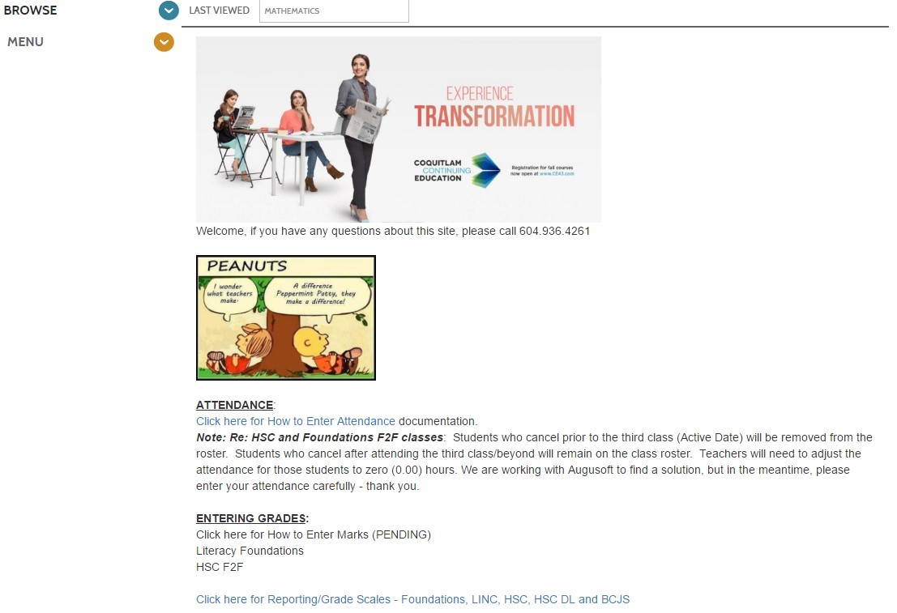

The document will open in a new window. Feel free to save and/or print the document for your use.
Step Two: Go back to the LUMENS window.
Step Three: Click MENU and then RECORD GRADES

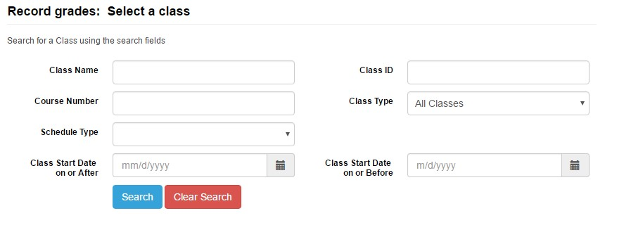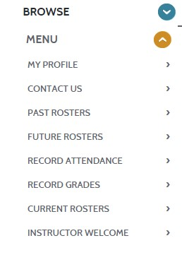
Step Four: Click the Blue search button and select your class.

Once you have selected the class, you will see a screen like the one below:

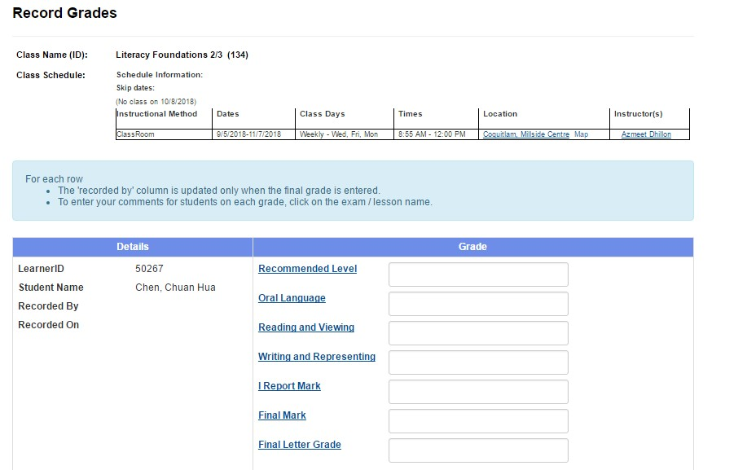

Using the Reporting/Grade Scales document provided at the bottom of this document, you will notice different values (“codes”) for different grades. Each section is used for different portions of the marks entry screen below.

Recommended Level: Enter 12 through 17; 21 though 27 or 30. You’ll notice they translate into the proper level just to the right of the field.
Individual Assessment Areas: The next few entry fields will vary depending on the type of Foundations class you teach. In this case, it lists Oral Language, Reading and Viewing and Writing and Representing. Enter 1 through 4 for these areas (1-Exceeding, 2-Fully Meeting, 3-Developing, 4-Not Yet Meeting).
I Report: leave blank. (In the unlikely event you are providing an I Report, please enter a zero, “0” in the field and click on the “I Report Mark” to open the Comments section).

Final Mark: Enter 1 though 4 (1-Exceeding, 2-Fully Meeting, 3-Developing, 4-Not Yet Meeting).
Final Letter Grade: Enter 5 (A) through 10 (F) for the Final Letter Grade.

BE SURE TO HIT THE SAVE BUTTON AT THE BOTTOM OF THE SCREEN
WHEN YOU HAVE COMPLETED YOUR ENTRIES.

Further instructions:
- Do you have students who withdrew during the term? Enter:
  - Recommended Level (use your best judgement. Your class roster has their level from the beginning of the term, it could make sense to enter this).
  - Oral Language/Reading & Viewing/Writing & Representing: most likely you will enter “4” (Not Yet Meeting)
  - I Report: leave blank
  - Final Mark: “4”
  - Final Letter Grade: The student must have a letter grade (A-F) or a W, as follows:
- Students who do not complete 65% of the course work or 65% of the hours of instruction (55 actual hours attended) must be given a “W” as their Final Grade.
- Students who do complete 65% of the course work or 65% of the hours of instruction (55 actual hours attended) must be given a Final Grade other than “W”. (FYI: Grad adults must have a final grade other than W in order to be funded)
- 65% of the coursework means 5 solid assignments, one midway assessment, and one final assignment, for a total of 7 entries.

- To check your marks are entered properly:
  - Click the blue Save button at the bottom, it takes you to a screen displaying your marks. At the bottom of this screen is a list of options that includes Download as Excel. Clicking this produces a spreadsheet, which you’ll see is properly displaying your marks other than the letter grade, which I’ll be converting myself.

REPORTING GRADE SCALES IN LUMENS
Foundations & Companion:
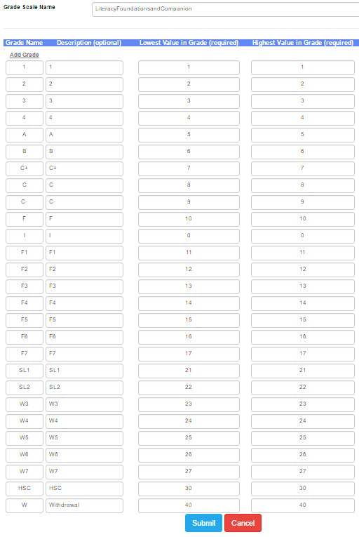

FOUNDATIONS TEACHER CHECK LIST

End of Course Checklist

ITEMS TO BE SUBMITTED TO MONTGOMERY OFFICE/GLENEAGLE OFFICE AT THE END OF EACH COURSE.

PLEASE ATTACH THIS SHEET TO EACH SET OF COURSE MATERIALS

Teacher Name (please print) _________________________________________________
Course Name ________________________________________ Course Code __________

1. A printed course outline

2. A Record of assignment marks (the teacher grade book, marks sheet, spreadsheet, hand recorded marks that you kept outside of Lumens this term) that records student achievement is printed and submitted to the office at the end of each course.
(a) The final report card marks in Lumens should be supported by your grade book.
(b) The grade book should refer to the learning outcome rather than list assignment numbers (ie: “short paragraph assign” rather than “task 1”).
3. Work sample, marked by teacher. Include a final assignment for each student. Students who initially attended but then withdrew also require an assignment.

Don’t print out any report card or final marks for students; this data is stored in Lumens and retrievable in the event of an audit.

(See reporting memo for detailed instructions (attached OR CE Intranet/Foundations sharing centre).

