Career-Life Connections 12

Welcome to Career-Life Connections 12, a course to assist you in transitioning to your first year after earning your high school diploma. The focus of this course is to have you begin researching and reflecting on different pathways that you could take after you graduate, to help you prepare for employment and ensure that you have a balanced lifestyle.

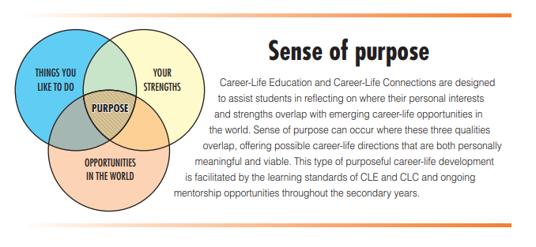

This course involves assignments that will ultimately lead you towards a Capstone project, presented on a date established by the teacher in consultation with the student. Each of the assignments is designed to have you reflect on your plans for next year and give you some support in preparing. All assignments will be handed in via email or dropped off at the Learning Centre.

Written Assignments:
- Who am I Assignment – 10%
- Sense of Purpose and Mentoring and Networking Assignment – 10%
- Budgeting Assignment – 10%
- Career Explorations Assignment – 10%
- Balanced Lifestyle Assignment – 10%

Capstone Presentation – 50%
The capstone is an opportunity for students to showcase their strengths, passions, and learning journey to a relevant audience. As a celebration of their learning journey, students are encouraged to share successes both in school and out of school, including their contributions and aspirations, and their possible postgraduation plans. The capstone can take many different forms, depending on student needs and interests. Each student will work on an individualized capstone, which will lead to a 15+ minute presentation based on an agreed upon schedule with the teacher.

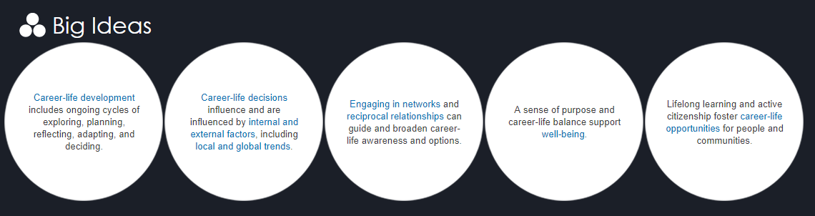

Evaluation

Assignments
Assignments will be introduced one at a time. Once your assignment is completed submit for assessment. A new assignment will be given out after the previous one has been marked and feedback given. Please submit assignments via email or you can drop them off in person. They will be marked on a grading rubric and a final percentage will be reported on the report card upon completion of the Capstone.

Capstone

Your presentation date: _________________________.

Work Experience

30+ hours requirement met

Teacher Name: Wally Sawchuk
Email: wsawchuk@sd43.bc.ca

Emerging  50-59%  C- | Developing  60 - 72%  C/C+ | Proficient  73 - 85%  B | Extending  86 - 100%  A
- all questions completed  - limited in detail  - vague examples given to support ideas  - no connections made to future plans  - no personalization or creativity added | - some detail added to a few questions  - few examples given to support ideas  - poor connections made to future plans  - all assignments have been completed  - little personalization or creativity added | - detail added to all questions  - examples given to support ideas  - connections made to future plans  - writing has some details  - personalization and creativity added | - reflections are thoughtful and include specific examples to support ideas  - clear connections made to future plans  - writing is strong, depth in detail, gone above and beyond the basic requirements  - clearly identifies personal traits with great detail and creativity

Work Habits

Criteria | N | S | G
Works Independently | Assignments not completed on time. Requires intervention from CLC teacher | Assignments usually completed on time, may require a reminder from CLC teacher | Assignments completed and submitted on time.
Initiative | Has difficulty starting to work; doesn’t ask for help. | Participates when asked; begins to work when assignment given; works hard most of the time | Begins to work on assignments without needing reminders. Asks questions when clarification required
Capstone | Struggles to choose a capstone project and needs numerous reminders to get started. | Discusses capstone when prompted and has documented some progress | Clear idea of what to do for capstone. Keen to get started, clearly documents progress.

