COQUITLAM LEARNING OPPORTUNITY CENTRE
104–2748 Lougheed Highway, Port Coquitlam, BC V3B 6P2
phone: 604.945.4211
CLOCoffice@sd43.bc.ca

STAFF SCHEDULE (2023-2024)
Information about subject specialists will be provided at registration.

 | MONDAY | TUESDAY | WEDNESDAY | THURSDAY | FRIDAY
10:00am-2:00pm | Karen  Marg | Christie  Stanley | Christie  Karen  Marg | Karen  Stanley | Christie  Marg
2:00pm-4:00pm | LEARNING CENTRE CLOSED |  |  |  | CLOSED
4:00pm-9:00pm | Karen (4-9pm)  Stanley (4-9pm)  Kishore  (4:30-9pm)  Wally (4:30-9pm) | Karen (4-8:30pm)  Marg (4-9pm)  Angus (4:30-9pm) | Christie (4-9pm)  Stanley (4-9pm)  Paul (4:30-9pm)  Wally (4:30-9pm) | Christie (4-8:30pm)  Andrea (4:30-9pm)  Marg (4:00-9pm)  Angus (4:30-9pm)  Paul (4:30-9pm) | CLOSED
Academic Advising  3:00pm-8:00pm |  | Patrick |  | Patrick | CLOSED

2023/2024 SCHOOL SCHEDULE
Coquitlam Learning Opportunity Centre will be CLOSED for the following statutory and school holidays:

Truth & Reconciliation Day | Monday, October 2, 2023
Thanksgiving Day | Monday, October 9, 2023
District Closure Day | Friday, November 10, 2023
Remembrance Day | Monday, November 13, 2023
Schools close for Winter Break | Friday, December 22, 2023
Schools reopen after Winter Break | Monday, January 8, 2024
BC Family Day | Monday, February 19, 2024
Professional Development Day | Friday, February 23, 2024
Schools close for Spring Break | Friday, March 15, 2024
Good Friday | Friday, March 29, 2024
Easter Monday | Monday, April 1, 2024
Schools reopen after Spring Break | Tuesday April 2, 2024
Closed for ACE Conference | Thursday, May 16, 2024
Closed for ACE Conference | Friday, May 17, 2024
Victoria Day | Monday, May 20, 2024

Last day before summer closure is June 28, 2024. CLOC will re-open Sept. 4, 2024
www.ce43.com www.graduate43.ca

COQUITLAM LEARNING OPPORTUNITY CENTRE
104–2748 Lougheed Highway, Port Coquitlam, BC V3B 6P2
phone: 604.945.4211
CLOCoffice@sd43.bc.ca

REGISTRATION HOURS
Course registration can be completed online at www.ce43.com or in person at CLOC during the following hours: Monday-Friday 10:00am-2:00pm or Monday-Thursday 4:00pm-8:00pm.

PARKING RESTRICTIONS
Parking restrictions are in effect daily. Vehicles will be towed. Please park only in the student parking areas identified (circled) below.

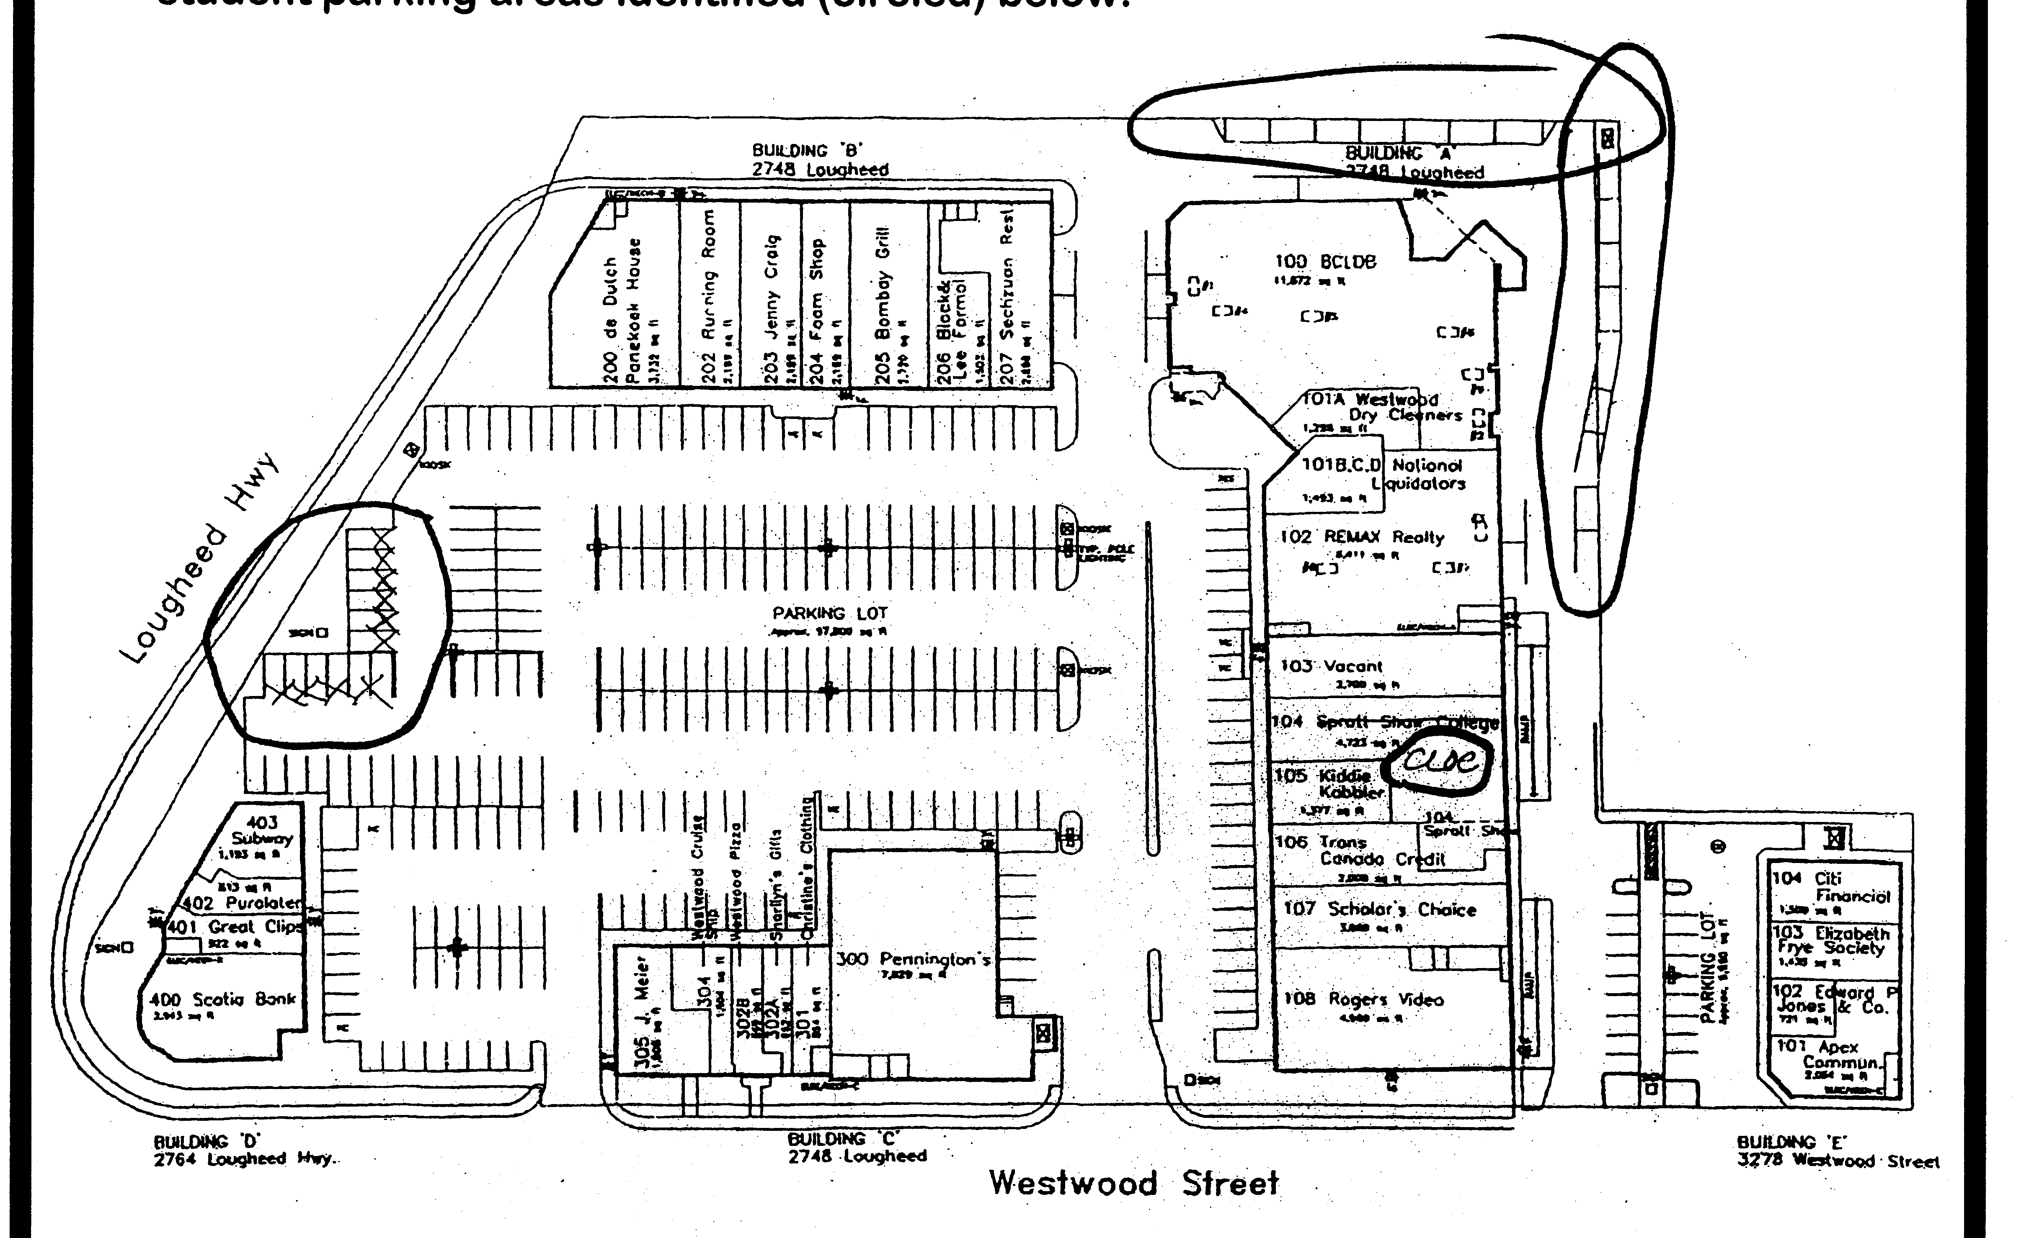
STUDENT
PARKING
#29 ‒ #40

PHOTO IDENTIFICATION
All students in self-paced high school credit courses at CLOC must provide photo identification when writing tests. Please be prepared to show photo identification every time you come to write a test.

www.ce43.com www.graduate43.ca

