How to add the new CEAccounts shared mailbox into Outlook

- Open Microsoft Outlook.
- For Windows 7 - click on the “File” tab on the top left corner. For Windows XP, click on “Tools”, then “Account Settings” (then go on step 4).

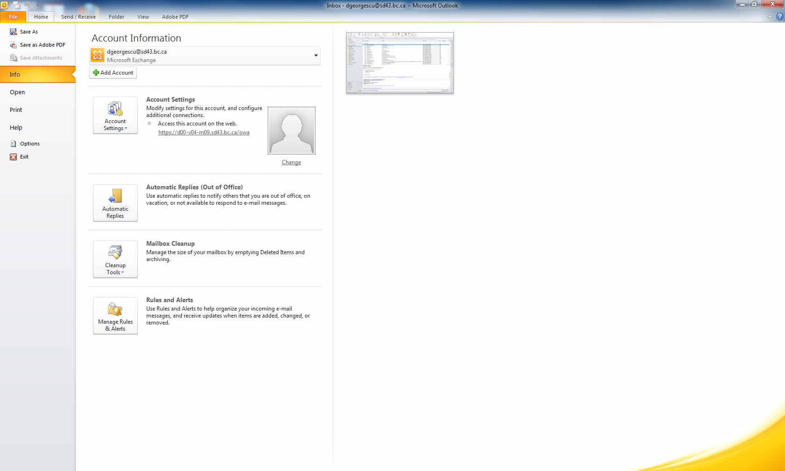

- Click on “Account Settings”.

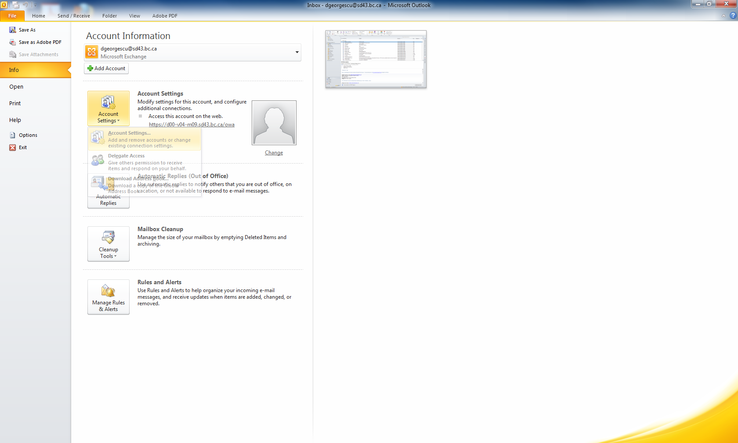

- Double-click on your mailbox name:

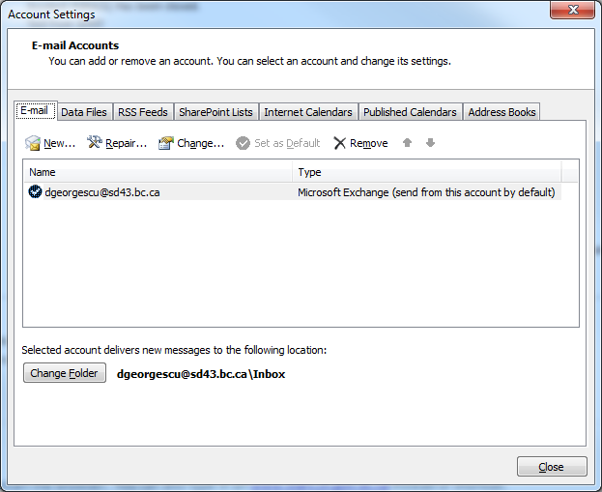

- Click on “More Settings”:

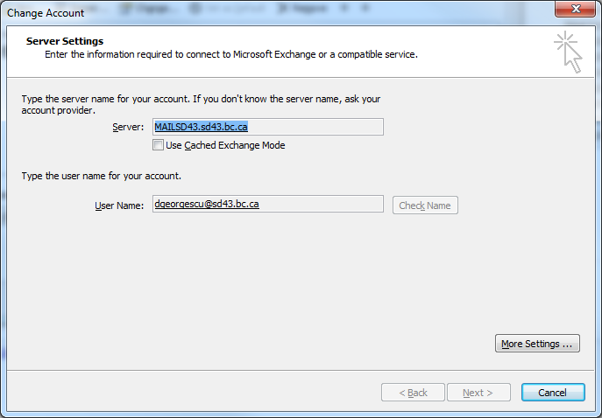

- Click on “Advanced”:

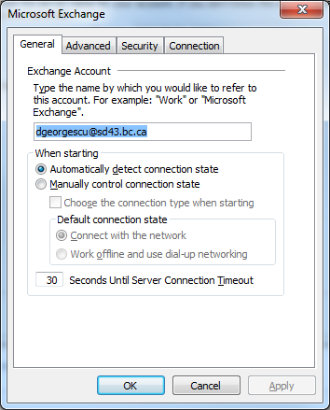

- Click on the “Add” button:

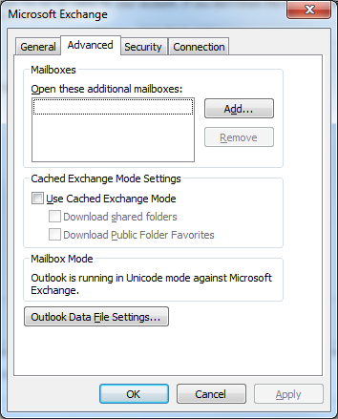

- Type “ceaccounts” and hit “OK”:

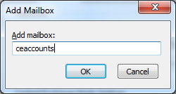

- You’ll get the below screen:

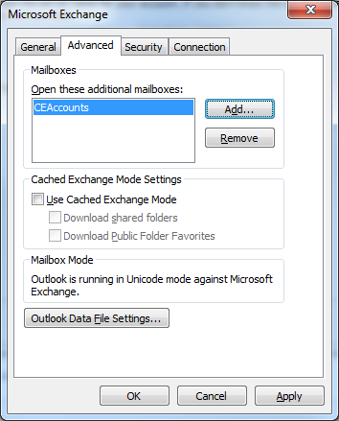

- Click on “OK”:

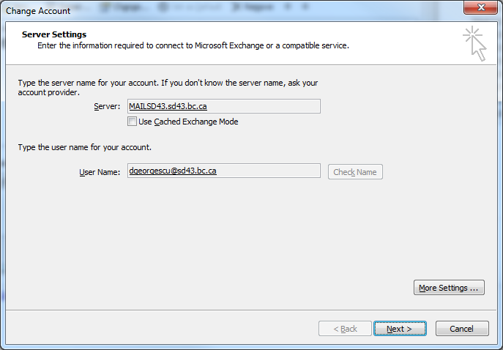

- Click on “Next”, then “Finish”. On Windows XP, after you click on the “Next” button, you’ll be directed to click on “Close”.

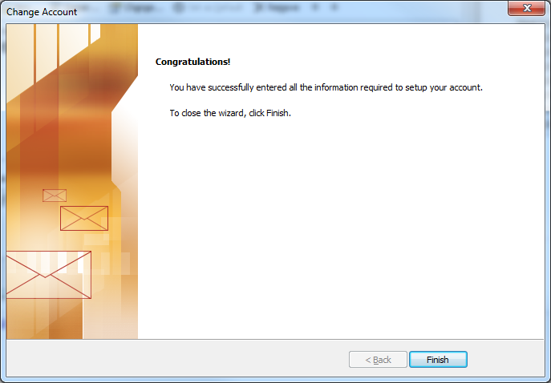

- Click on “Close”:

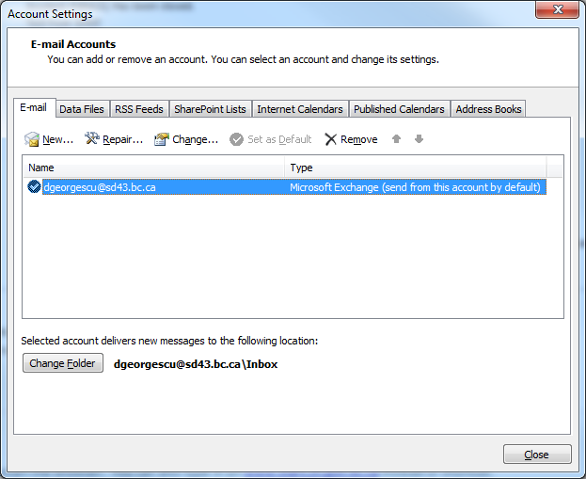

- The new “CEAccounts” shared Inbox would appear as below:

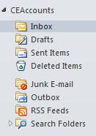

- When working on an email it will get marked as “Read”, so the others would not work on it. Once you’re done with your email, simply delete it. It will get moved to your own “Deleted Items” folder, not within the “CEAccounts”, in case you’d want to recall a deleted email.
- In case you’d want to place an email “back to be checked by others”, right click on it and hit “Mark as Unread”.

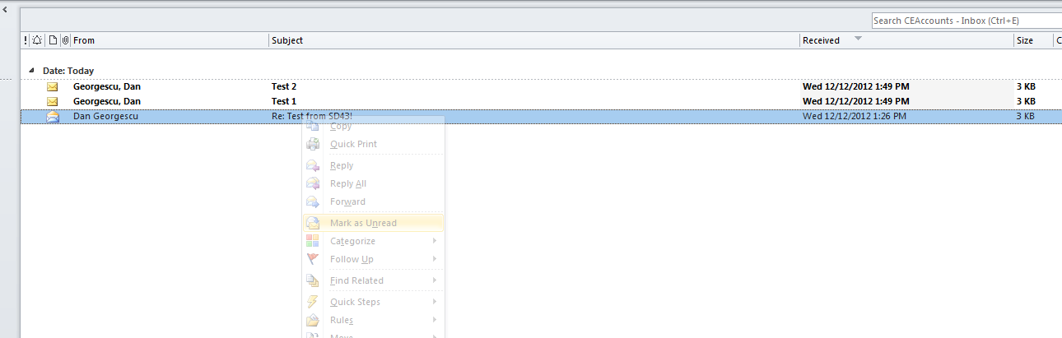

- When sending emails out to the students, send them on behalf of CEAccouns as below:
- Click on “New email” as you’d regularly do, then click on “Options”:

- Click on “From”:

- Expand the “From” drop down:

- Click on “Other Email Address”:

- Type “ceaccounts” and hit OK.

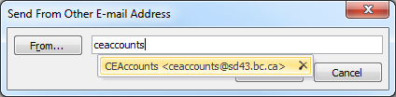

- Go ahead and send your email out on behalf of the CEAccounts account. For any student that would reply back to your email, you’ll get a new email into the Inbox of this shared Inbox. Anyone (Continuing Education Secretary email group) will be able to see all the emails in this shared Inbox.

- The email templates have been placed on SharePoint, under my43, Documents, Office Staff, Account Approval Emails.

http://my43.sd43.bc.ca/schools/CE/Office%20Staff/Forms/AllItems.aspx?RootFolder=%2fschools%2fCE%2fOffice%20Staff%2fAccount%20Approval%20Emails&FolderCTID=&View=%7b7AED79BC%2dA19A%2d4A54%2d8DA1%2dE9DABE05372D%7d

- Feel free to email to dgeorgescu@sd43.bc.ca if you have any questions.

